**Assignment 3_3**

1. Test whether two vectors are exactly equal (element by element).

vec1 = c(rownames(mtcars[1:15,]))

vec2 = c(rownames(mtcars[11:25,]))

identical(vec1, vec2)



2. Sort the character vector in ascending order and descending order.

vec1 = c(rownames(mtcars[1:15,]))

vec2 = c(rownames(mtcars[11:25,]))

sort(vec1)-ascending

sort(vec2)-ascending

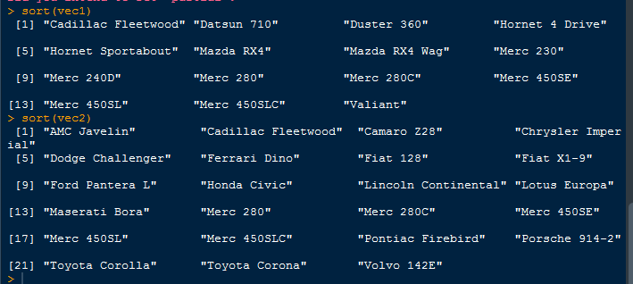

sort(vec1, decreasing=TRUE)

sort(vec2, decreasing=TRUE)

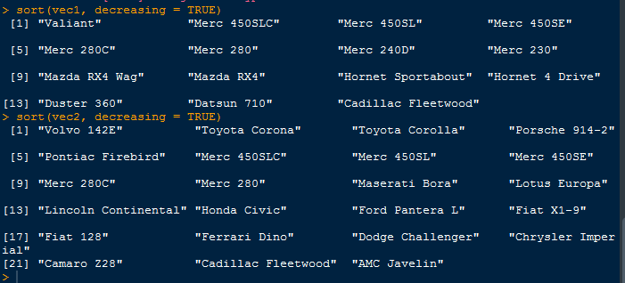

1. What is the major difference between str() and paste() show an example.

Str() –Provides details of an object.

Paste()-Concatenates the strings.

4. Introduce a separator when concatenating the strings.

> paste("acad","gild",sep="-")

[1] "acad-gild"

> cat("acad","gild",sep="-")

acad-gild